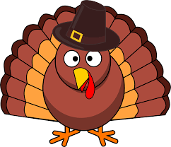Thanksgiving Lunch

Dear Parents,

Our School cafeteria will be serving our traditional Thanksgiving meal on Friday, November 18. Our lunchtime is 10:30 to 10:50. If you would like to have lunch with us on this day, please send money by your child to Mrs. Grant at the front desk for a pre-paid ticket: tickets are $4.00 (please send correct amount, cash only) for visitors. We will send your ticket home to you with your child after we receive payment. The pre-sales allow us to better plan for our Thanksgiving meal.

If you decide to join us for lunch on November 18, we need to know by Tuesday, November 15. The doors by the cafeteria will be opened and there will be a table set up for you to sign in at. We look forward to hearing from you.

